RAAMS Users Letter Template

Instructions

Before submitting an application for funding to the Council’s Restoration Assistance and Award Management System (RAAMS), the Council Steering Committee Member or an appropriate senior official acting on behalf of the Steering Committee Member must:
1. Identify the agency that will execute the project or program, and the associated
official who can legally bind the agency and who will have oversight for the
administration and use of grant or interagency agreement (IAA) funds.
2. Designate at least one staff member who is authorized to enter, manage and
submit information and data in RAAMS on behalf of the agency
This template and the associated information is provided to assist in preparing and submitting these authorizations and designations to the Council. Please provide a letter or email in the format on the following page or a comparable format.
The template is designed to provide user designations for a single project. If designations will be provided for more than one project, please provide all applicable information from the template for each project.
At a minimum, each project or program must be individually listed with a corresponding agency, authorized official, and Primary RAAMS Contact identified.
Please send your completed document to the RAAMS program support email address: raams_pgmsupport@restorethegulf.gov.

Please note:
The authorization letter must be signed by the Council Steering Committee Member or an appropriate senior agency or departmental official.
A Primary Contact for each project or program for which an application will be submitted must be designated.
○ The Primary Contact will submit the application in RAAMS.
○ The Primary Contact must have completed RAAMS Training.
You may identify other users in the letter for informational purposes; the Primary Contact will be responsible for adding and managing users associated with the project in RAAMS.
RAAMS user permissions are project-specific and mutually exclusive. A user cannot have more than one permission level for any given project, but can have different permission levels for different projects. Please identify the permissions most appropriate for the specific user-project combination.
The Data Steward is a requirement of the Data Management Plan but is optional for this letter, as you may not yet know who will fulfill this role. It is included here for the convenience of gathering contact information in one document.

Additional information to assist in determining the appropriate RAAMS user permissions and example letter are provided in Attachments 1, 2 and 3. If you have any questions regarding this template or RAAMS user permissions, please contact Council staff Kristin Smith (kristin.smith@restorethegulf.gov) or Joshua Easton (joshua.easton@restorethegulf.gov). If you have questions regarding the Data Steward role, please contact Alyssa Dausman (alyssa.dausman@restorethegulf.gov).

[Date]

To: Mary Pleffner, CFO/Director of Administration, Gulf Coast Ecosystem Restoration Council
(submitted to raams_pgmsupport@restorethegulf.gov)

This letter identifies the agency that will execute the following project or program listed on the 12/9/2015 Funded Priorities List (FPL) and the official from that agency who will sign the [grant/Interagency Agreement (IAA)] and have oversight for the administration and use of Council funds.

Project/Program: [Project/Program Name - required]
Responsible Organization: [Responsible department or agency - required]
Authorizing Official: [Authorizing official for that organization - required]

The following person or persons is/are authorized to enter [select 1: grant/IAA] application information into the Restoration Assistance and Award Management System (RAAMS) for the project identified. This person will be the Primary Contact for entering, managing and submitting the application and subsequent tasks associated with the award in RAAMS.

- Primary Contact (required)

I authorize the Primary Contact listed below to submit an application for funding to the Gulf Coast Ecosystem Restoration Council through RAAMS on behalf of the [Responsible organization] for [Project/Program Name].

[Name]
[E-mail Address]
[Organizational Title]
[Phone Number]

- Do you wish to designate a Secondary Contact? [Yes/No]

[Name]
[E-mail Address]
[Organizational Title]
[Phone Number]
[Public Project File Access {Yes/No}]

- Do you wish to designate additional “Full Access” users? [Yes/No]

[Name]
[E-mail Address]
[Organizational Title]
[Phone Number]
[Public Project File Access {Yes/No}]

- Do you wish to designate “Data Entry” users? [Yes/No]

[Name]
[E-mail Address]
[Organizational Title]
[Phone Number]
[Public Project File Access {Yes/No}]

- Do you wish to designate one or more “Financial” users? [Yes/No]

[Name]
[E-mail Address]
[Organizational Title]
[Phone Number]
[Public Project File Access {Yes/No}]

- Do you wish to designate any “View Only” users? [Yes/No]

[Name]
[E-mail Address]
[Organizational Title]
[Phone Number]
[Public Project File Access {Yes/No}]

- Data Steward (if known)

[Name]
[E-mail Address]
[Organizational Title]
[Phone Number]

Signature

[Steering Committee Member or Agency Official]
[Title]
[Applicable Department or Agency Information]

RAAMS: Definition of Application Task Designations
Primary Contact
- Required for all project/program applications in RAAMS.
- One Primary Contact must be designated for each project or program prior to starting the application process.
- The Primary Contact must have completed RAAMS training.
- The Primary Contact is the only individual who can initiate the application, electronically sign the application, and submit the application in RAAMS.
- The Primary Contact is one of only two user designations able to create additional project personnel, the other being the Secondary Contact.
- The Primary Contact has full edit access for the entire application.
- The Primary Contact inherits ownership of all subsequent project tasks (revisions, progress reports, etc.) and receives email notifications regarding the project/program (e.g., notification of upcoming due dates).

Secondary Contact
- Optional Designation.
- The Secondary Contact is one of only two user designations able to create additional project personnel, the other being the Primary Contact.
- The Secondary Contact must be assigned by the Primary Contact.
- The Secondary Contact has full edit access for the entire application with the exception that he/she cannot edit the budget, electronically sign or submit the application.
- Has view-only access to the Budget screen.

Full Access
- Optional Designation.
- Assigned by either the Primary Contact or Secondary Contact.
- Has full edit access for the entire application with the exception that he/she cannot add other users, edit the budget, electronically sign, or submit the application.
- Has view-only access to the Budget screen.

Data Entry
- Optional Designation.
- Assigned by either the Primary Contact or Secondary Contact.
- Has edit access to the following data screens: Application Info, Organizations, Locations, Leveraged Funding, Tribal Support, Environmental Compliance, Uploads, Comprehensive Plan Criteria, Comprehensive Plan Narratives, Emphasis Areas, and Metrics.
- Has view-only access to the following data screens: Budget, Cash Forecasting, and Milestones.

Financial
- Optional Designation.
- Assigned by either the Primary Contact or Secondary Contact.
- Has view-only access to the following data screens: Application Info, Organizations, Locations, Leveraged Funding, Tribal Support, Environmental Compliance, Uploads, Comprehensive Plan Criteria, Comprehensive Plan Narratives, Emphasis Areas, and Metrics.
- Has edit access to the following data screens: Cash Forecasting and Milestones.
- Access to the Budget data screens (Budget Reassignment) can be requested by the Primary Contact.

View Only
- Optional Designation.
- Assigned by either the Primary Contact or Secondary Contact.
- Has view access to the entire application, but cannot edit or add values.

Public Project File Access
This is a special permission that is assigned independently of role or permission designations. Any user can be given public project file access. The Primary Contact always has this permission. Unlike the designations above, which are used to control permission to a task (such as the application) in RAAMS, public project file access controls access to the information in the award file. Users with this permission will be able to:
- See all tasks that have been completed by the applicant/recipient for a given project.
- Request Budget Reassignment to a Financial User.
- View all documents that have been uploaded for a given project.
- Assign themselves tasks from the award file, such as revision and amendment requests.

It is recommended that only a small number of users be given this permission. Over time, this permission will grant users access to a large amount of data.
Data Steward
This designates a principal point of contact with regard to the agencies data responsibilities for this project. The Data Steward may be same person fulfilling one of the roles above. Recipients are responsible for providing all project-related data to the Council:
- in digital, machine-readable, non-proprietary formats;
- described with appropriate metadata; and
- in compliance with all federal laws and policies.

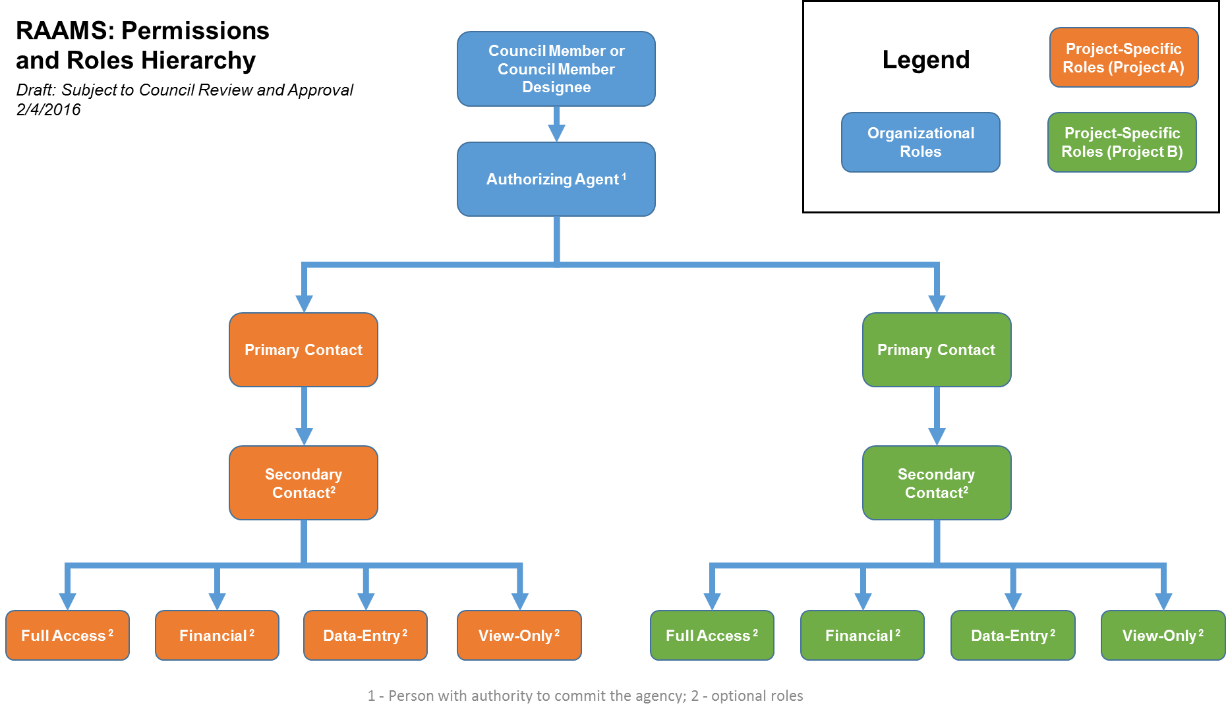

Example
In the example below, a senior-level official for the Department of Success has indicated the Primary Contact, as well as additional users, for its Category 1 project listed on the FPL.
Note that user permissions are project-specific and mutually exclusive. Only one permission level can be indicated per user per project. For instance, if a user is given financial permission to a given project, that user cannot also be assigned the “data-entry” permission. However, the same user can be assigned a “data entry” permission on a second project.
*Note: Items highlighted in blue represent data values entered by the individual signing the authorization letter.
*Note: Red italicized text indicates explanatory comments.

1-1-2020
To: Mary Pleffner, CFO/Director of Administration, Gulf Coast Ecosystem Restoration Council
(submitted to raams_pgmsupport@restorethegulf.gov)
This letter identifies the department that will execute the following project or program listed on the 12/9/2015 Funded Priorities List (FPL) and the official from that department who will sign the grant award or Interagency agreement (IAA) and have oversight for the administration and use of Council funds.
Project/Program: Golden Island Restoration
Responsible Organization: Department of Success
Authorizing Official: John Jacob Jones, Director, Restoration Division
The following person is authorized to enter grant or IAA application information into the Restoration Assistance and Award Management System (RAAMS) for the project identified. This person will be the Primary Contact for entering, managing and submitting the application and subsequent tasks associated with the award in RAAMS.
- Primary Contact (required)
I authorize the Primary Contact listed below to submit an application for funding to the Gulf Coast Ecosystem Restoration Council through RAAMS on behalf of the Department of Success for the Golden Island Restoration project.
Jordan Allstar
Jordan.Allstar@success.gov
Program Manager
111-111-1111

- Do you wish to designate a Secondary Contact? [Yes]
Bailey Secondstar
Bailey.Secondstar@success.gov
Project Manager
222-222-2222
[Public Project File Access {Yes}]
- Do you wish to designate additional “Full Access” users? [Yes]
Pat Allstar
Pat.Allstar@success.gov
Data Analyst
333-333-3333
[Public Project File Access {Yes}]

- Do you wish to designate “Data Entry” users? [Yes]
John Smith
John.smith@contractor.com
Project Manager
444-444-4444
[Public Project File Access {No}]
*Because John Smith is a contractor, he has not been given Public Project File Access. Data within Public Project File Access may include sensitive information.
Courtney Smith
Courtney.Smith@subrecipient.org
Project Manager
777-777-7777
[Public Project File Access {Yes}]
*Although this user is not a member of the prime organization, because he/she will be conducting much of the work for this project, the Department of Success has decided to extend Public Project File Access. Data within Public Project File Access may include sensitive information.
- Do you wish to designate one or more “Financial” users? [No]

- Do you wish to designate any “View Only” users? [Yes]
Jane Smith
Jane.Smith@contractor.com
Biologist
555-555-5555
[Public Project File Access {No}]
*Because Jane Smith is a contractor, she has not been given Public Project File Access. Data within Public Project File Access may include sensitive information.
- Data Steward (if known)

Casey Datastar
Casey.Datastar@success.gov
Data Manager
999-999-9999

Signature
Successful Designee {signature}, Executive
Director
Department of Success

